Matlab 第四章作业  
2017301020181 仁青尖参  
解题分析  
1由图中Mable二极管公式可得知 q k d 等变量需要人为输入 是由该二极管材料的属性及二极管的型号决定的 因此建立图形用户交互界面gui来手动输入此三项参数的值  
2将此二极管的电流-电压 曲线分为两部分 击穿时与未击穿 由于在特定参数下该段的数量级相差较大分别在交互式图形界面设置两个按钮来表示这两段的I-V曲线  
3将所得结果截图上传  
解题过程  
1将已知的参数如T 等在程序前定义  
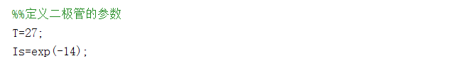  
2设计编辑框来得到未知参数的值，并且设置坐标轴来表示I-V曲线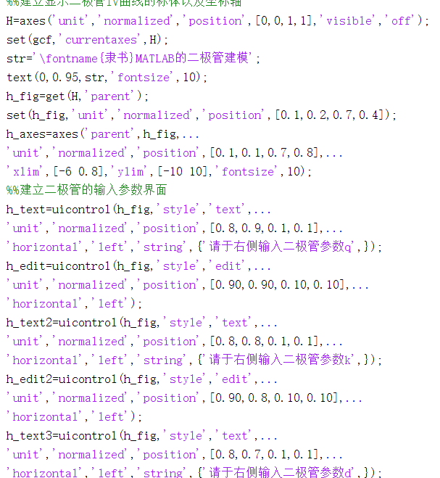  
3设置按钮分别作击穿以及未击穿时的I-V图像

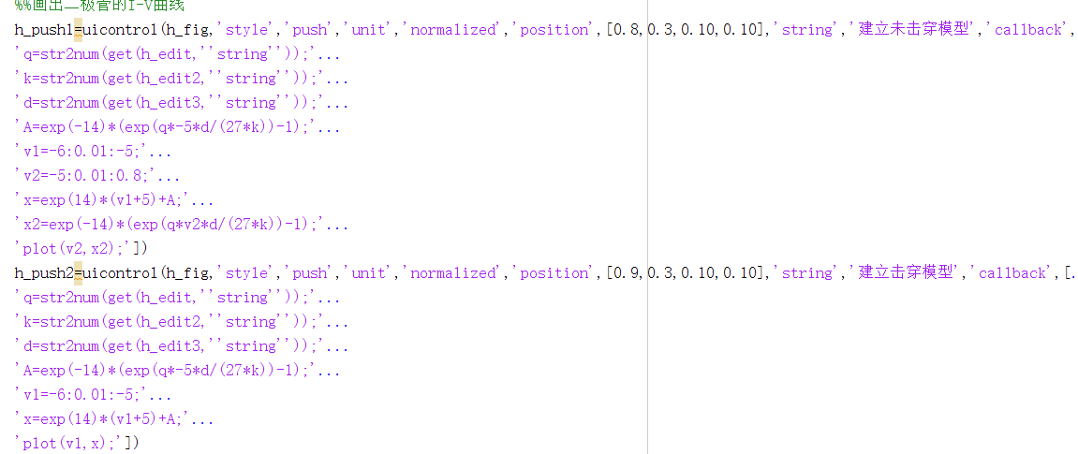  
结果如图 以 q=5 k=7 d=9 为例子  
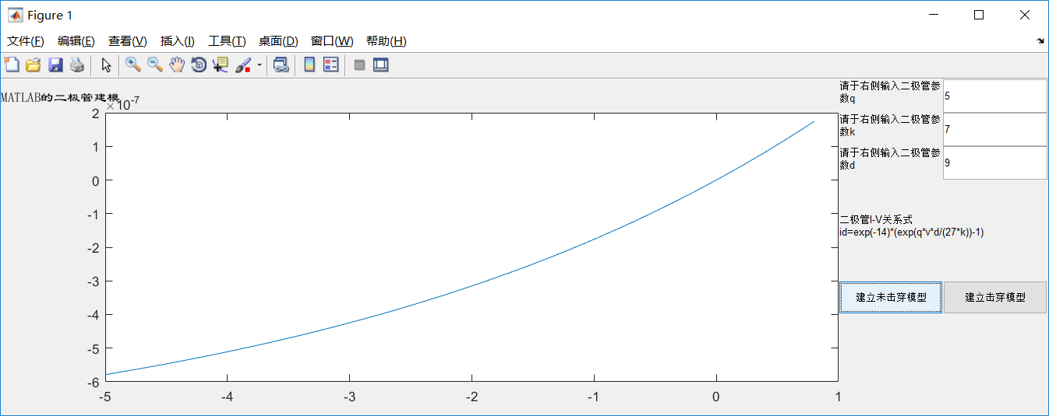  
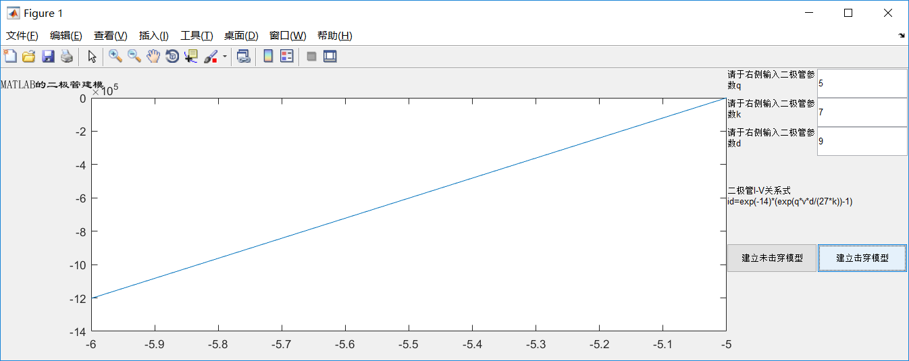  
附 该m文件的代码  
%%%%%%%%%%%%%%%%%%%%%%%%%%%%%%%%%%%%%%%%%

%%% file name: matladhomework chapter4.m

%%% author: 仁青尖参

%%% version: 1.0

%%% update time: 10/26/2019

%%%%%%%%%%%%%%%%%%%%%%%%%%%%%%%%%%%%%%%%%%

%%定义二极管的参数

T=27;

Is=exp(-14);

%%建立显示二极管IV曲线的标体以及坐标轴

H=axes('unit','normalized','position',[0,0,1,1],'visible','off');

set(gcf,'currentaxes',H);

str='\fontname{隶书}MATLAB的二极管建模';

text(0,0.95,str,'fontsize',10);

h_fig=get(H,'parent');

set(h_fig,'unit','normalized','position',[0.1,0.2,0.7,0.4]);

h_axes=axes('parent',h_fig,...

'unit','normalized','position',[0.1,0.1,0.7,0.8],...

'xlim',[-6 0.8],'ylim',[-10 10],'fontsize',10);

%%建立二极管的输入参数界面

h_text=uicontrol(h_fig,'style','text',...

'unit','normalized','position',[0.8,0.9,0.1,0.1],...

'horizontal','left','string',{'请于右侧输入二极管参数q',});

h_edit=uicontrol(h_fig,'style','edit',...

'unit','normalized','position',[0.90,0.90,0.10,0.10],...

'horizontal','left');

h_text2=uicontrol(h_fig,'style','text',...

'unit','normalized','position',[0.8,0.8,0.1,0.1],...

'horizontal','left','string',{'请于右侧输入二极管参数k',});

h_edit2=uicontrol(h_fig,'style','edit',...

'unit','normalized','position',[0.90,0.8,0.10,0.10],...

'horizontal','left');

h_text3=uicontrol(h_fig,'style','text',...

'unit','normalized','position',[0.8,0.7,0.1,0.1],...

'horizontal','left','string',{'请于右侧输入二极管参数d',});

h_edit3=uicontrol(h_fig,'style','edit',...

'unit','normalized','position',[0.90,0.7,0.10,0.10],...

'horizontal','left');

h_text4=uicontrol(h_fig,'style','text',...

'unit','normalized','position',[0.8,0.4,0.2,0.2],...

'horizontal','left','string',{'二极管I-V关系式 id=exp(-14)*(exp(q*v*d/(27*k))-1)',});

%%画出二极管的I-V曲线

h_push1=uicontrol(h_fig,'style','push','unit','normalized','position',[0.8,0.3,0.10,0.10],'string','建立未击穿模型','callback',[...

'q=str2num(get(h_edit,''string''));'...

'k=str2num(get(h_edit2,''string''));'...

'd=str2num(get(h_edit3,''string''));'...

'A=exp(-14)*(exp(q*-5*d/(27*k))-1);'...

'v1=-6:0.01:-5;'...

'v2=-5:0.01:0.8;'...

'x=exp(14)*(v1+5)+A;'...

'x2=exp(-14)*(exp(q*v2*d/(27*k))-1);'...

'plot(v2,x2);'])